**PROJECT REPORT**

**OBJECT ORIENTED PROGRAMMING**

**SEMESTER - 2**

**NAME OF PROJECT -** HOTEL MANAGEMENT SYSTEM

**MADE BY -** AVNEET KAUR

**ROLL NO -** CO21312

**SUBMITTED TO -** DR. SARABJIT SINGH

**INTRODUCTION**

A hotel is an establishment that provides lodging paid on a short-term basis. Facilities provided may range from a basic bed and storage for clothing, to luxury features like en-suite bathrooms. Larger hotels may provide additional guest facilities such as a swimming pool, business center, childcare, conference facilities and social function services. Hotel rooms are usually numbered (or named in some smaller hotels and B&BS) to allow guests to identify their room. Some hotels offer meals as part of a room and board arrangement. In the United Kingdom, a hotel is required by law to serve food and drinks to all guests within certain stated hours. In Japan, capsule hotels provide a PROJECT ON HOTEL MANAGEMENT SYSTEM 6 minimized amount of room space and shared facilities.

**ABOUT THE PROJECT**

* It covers macros, classes, objects, arrays, functions, loops, and structure in this project for C++ novices.
* When this code is launched, the user is presented with a menu with seven options numbered 1 through 7, after which the program executes according to the user's choices.
* The output from the g++ compiler may be seen at the bottom of the report.

**MAIN FEATURES OF THE PROJECT ARE :**

* **Manage rooms:** In this project we can manage how many rooms are available or booked .
* **Guest Check-In & Check-Out:** Using this project we can monitor the guest check-in or check-Out activities with time.
* **Get available rooms:** We can get all available rooms.
* **Search customer:** Using this we can search any customer or guest, is he/she still available in the hotel or not.
* **Get guest summary report:**  We will get the summary details of guests using this project.

**HEADER FILES USED :**

* #include<iostream>
* #include<string.h>
* #include<conio.h>
* #include<fstream.h>
* #include<dos.h>
* #include<process.h>
* #include<stdlib.h>
* #include<stdio.h>
* #include<ctype.h>

**IMPLEMENTATION OF HOTEL MANAGEMENT SYSTEM :**

**Step 1.** Create a new **Project** inCODEBLOCKS

**Step 2.** First of all we will include all **header** **files** which will be used in the project.

**Step 3.** Add the following line below **header** file:

The using **namespace** statement simply implies that in the scope in which it is present, all items in the std namespace are available without needing to prefix them with std:

**Step 4.** Now we will create a class(**customer**) which can take the details of the customer

**Step 5.** Now we will create a class(**room**) which can take the details of the room.

**Step 6.** Now we will create function to **add** **room**, **search** **room** and **display** **room**

**Step 7.** Now we will create class(hotel management) which include these function:

1. Checkin

2. getAvailRoom

3. searchCustomer

4. checkout

5. guestSummaryReport

**1. Check-in :** check all the customer details like booking id: **name, address, advance payment, from date, to date**.

**2. getAvailRoom** : It shows all the available rooms in the hotel.

**3. Search customer:**  It shows all persons that have booked a room.

**4. Checkout:** It generates the bill of the expenses and remaining payment of the customer.

**5. GuestSummaryReport:** It gives the details of the customer.

**Step 8.** Here we can see the **main menu** of the project and Use the switch statement to select one of many code blocks to be executed.

**Step9**. Finally we create the main function. It is a special function that is the primary function. A function called main is required in every C++ application. It acts as the program's starting point. The computer will begin running the code from the main function's beginning.

**OUTPUT**

* MAIN SCREEN

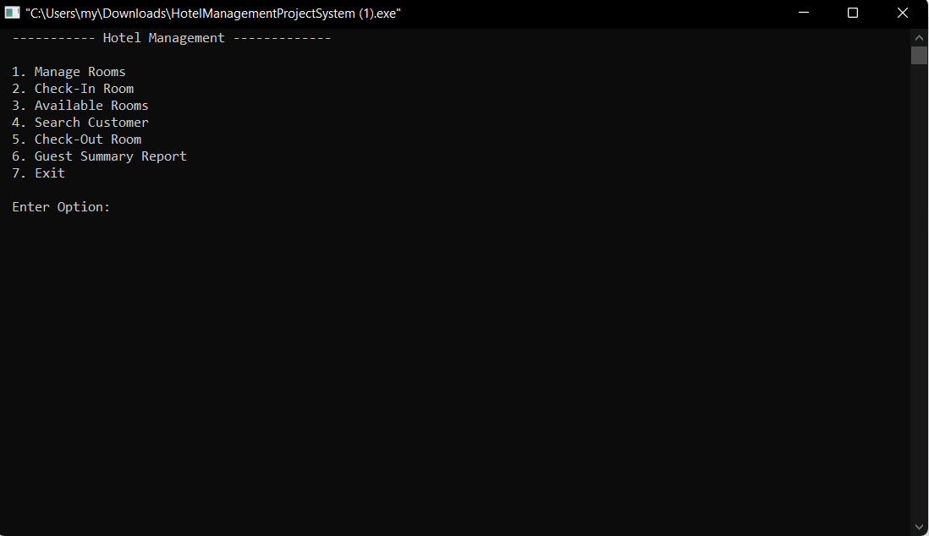

* MANAGE ROOMS

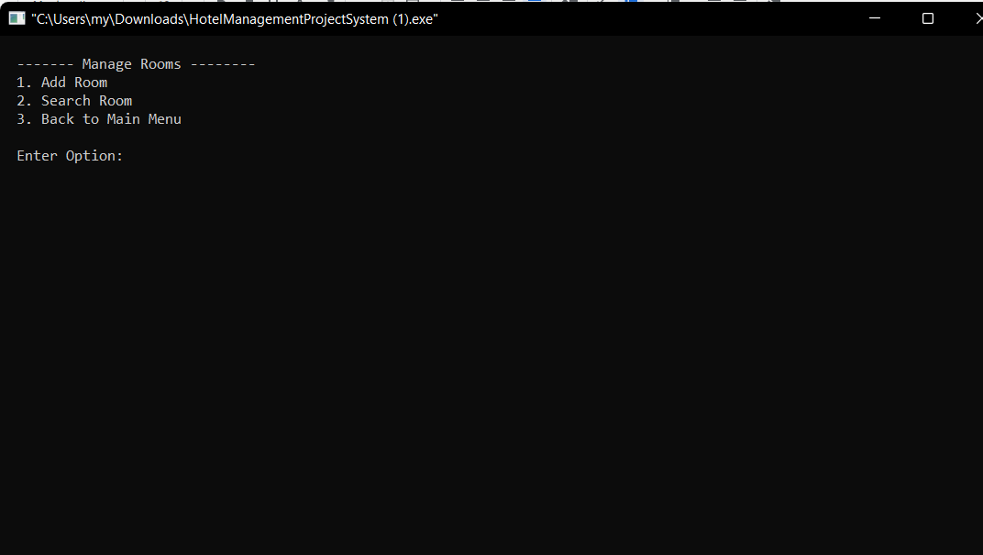

* ADD ROOM

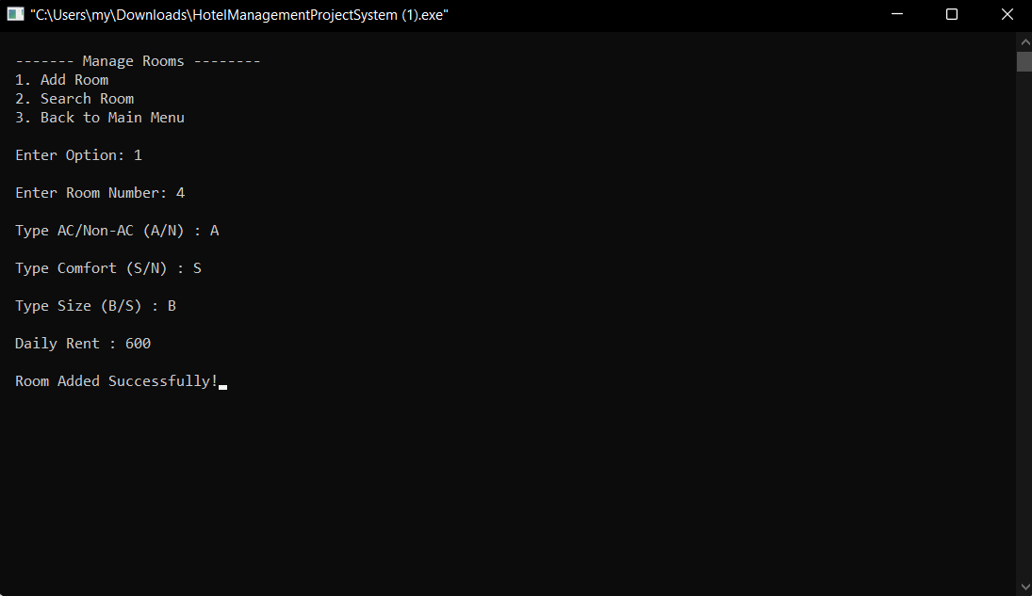

* SEARCH ROOM

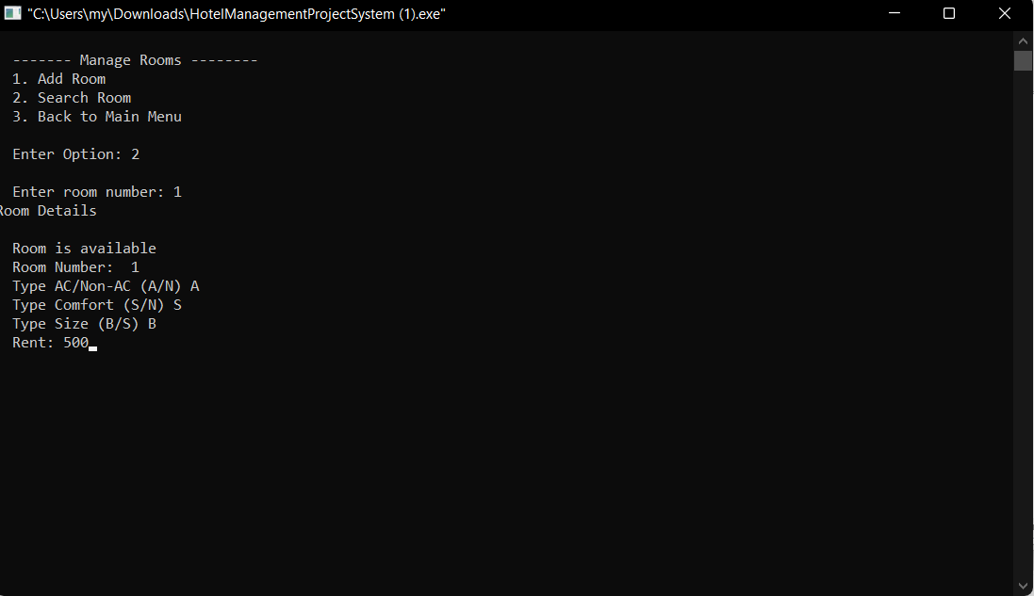

* CHECK-IN ROOM

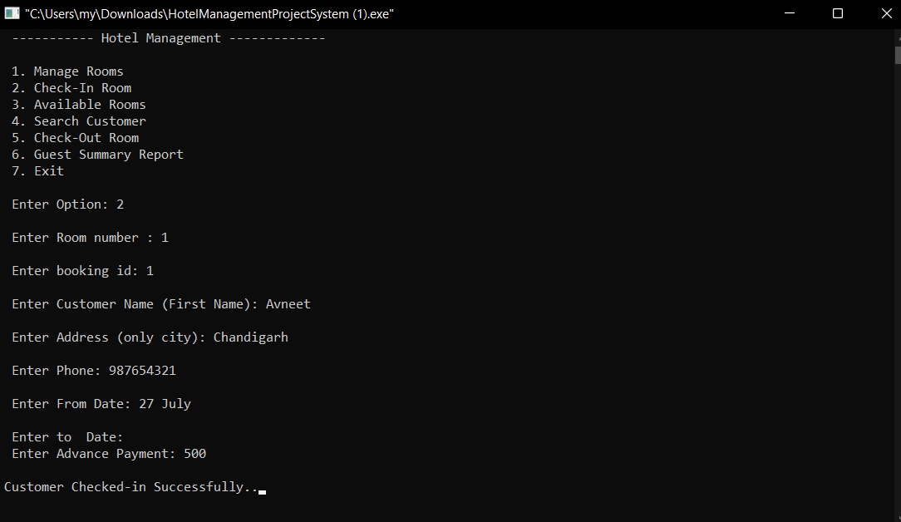

* AVAILABLE ROOMS

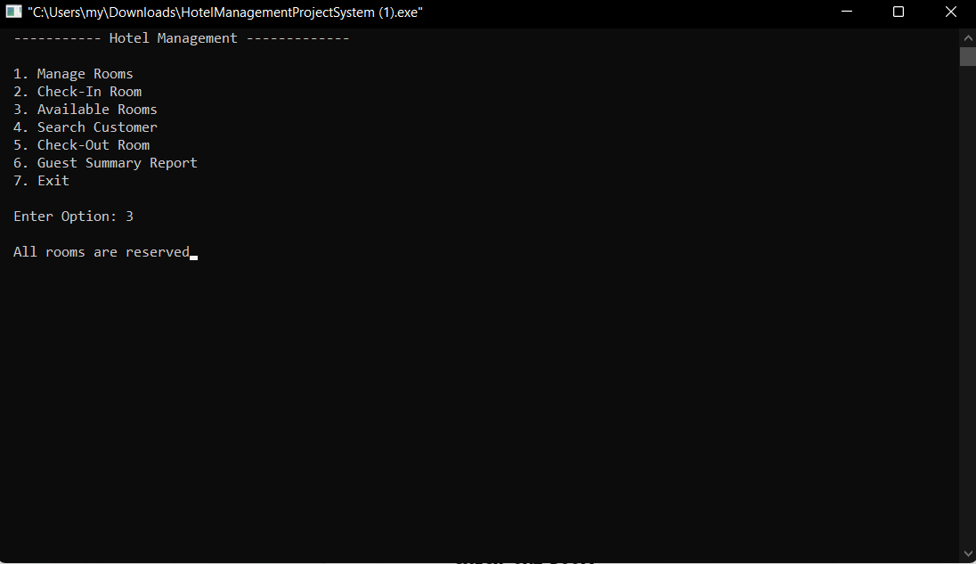

* SEARCH CUSTOMER

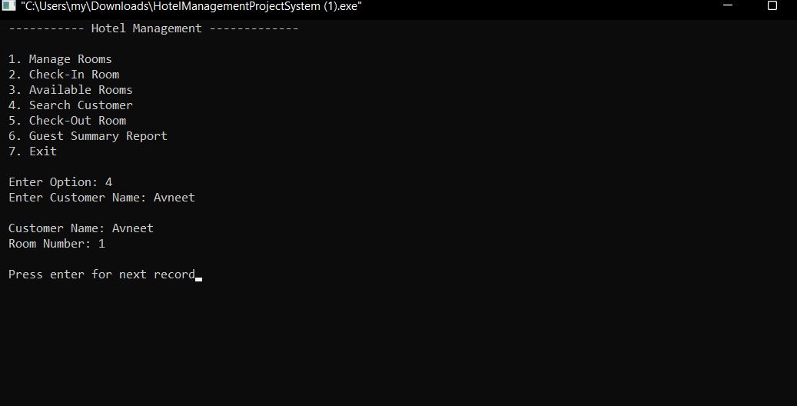

* CHECK-OUT ROOM

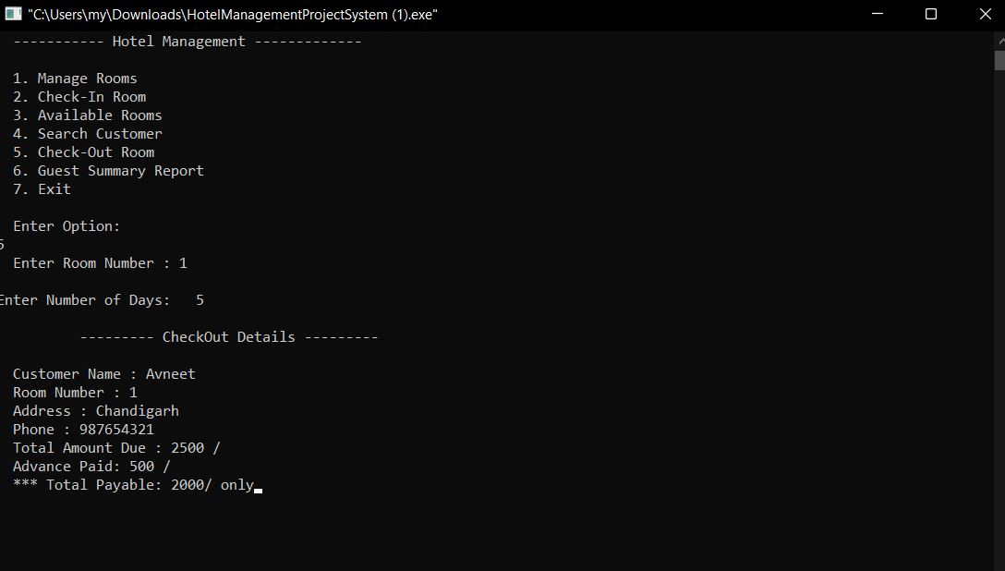

* GUEST SUMMARY REPORT

